**Our Features**

**First feature - Find a Ride**

Enables the user to find a ride to work/academic institution/event with one of his friends.

Our system displays to the user all the cities where his friends live. If one of this start locations relevant to the user, he needs to choose it and the next operation is to select where he needs a ride.

The system search in user's friends all of the relevant matches and displays it to the user.

**Second feature - Create Collage**

Enables the user to create a collage of his photos.

The user has to select one of a proposed skeletons and photos to put on the collage and the system creates for him a collage with his chosen photos.

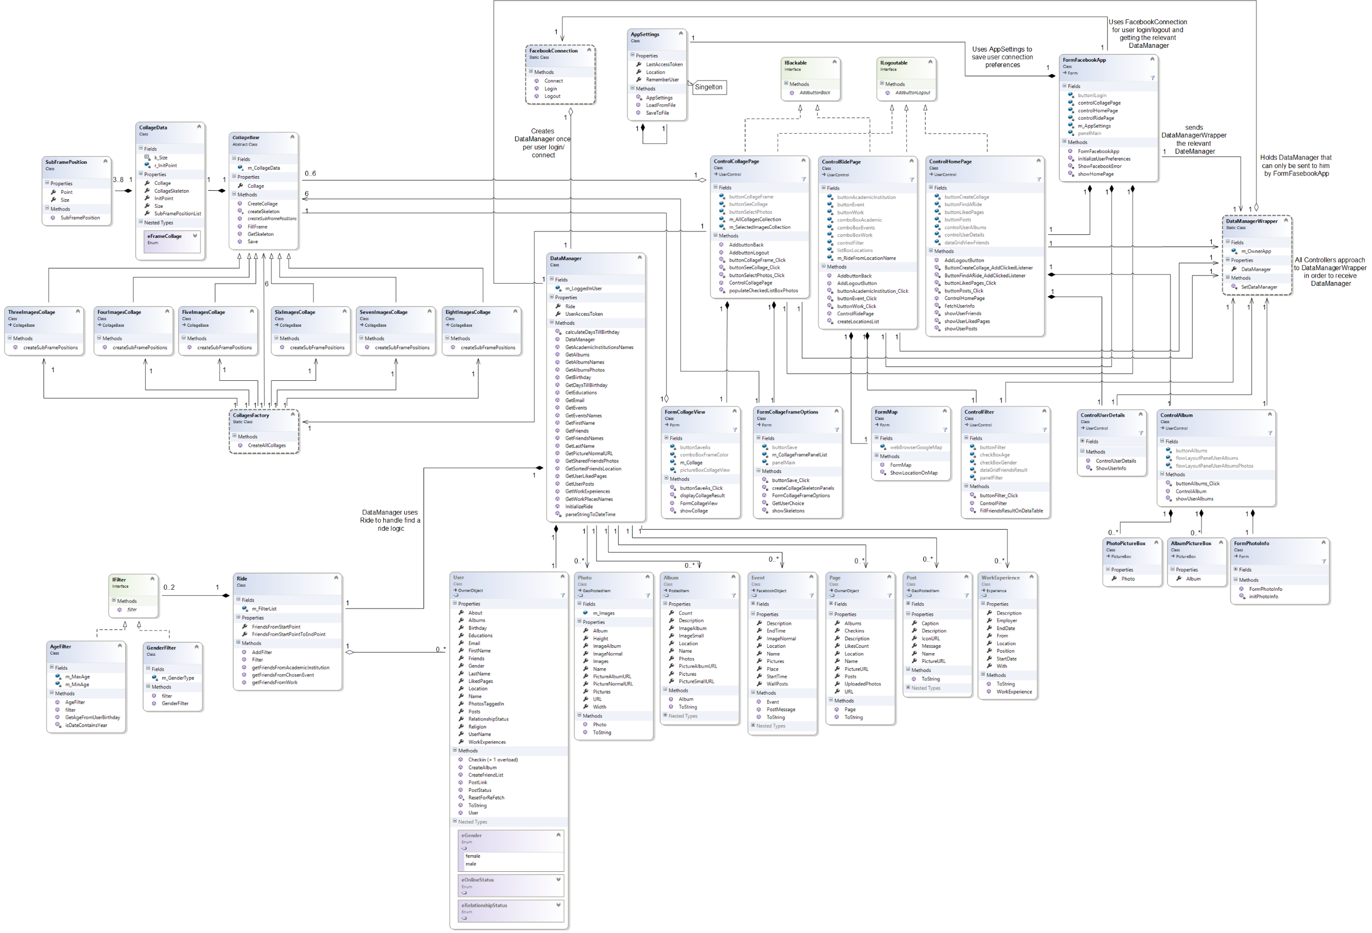**Class Diagram:**

**Use Case Diagram:**

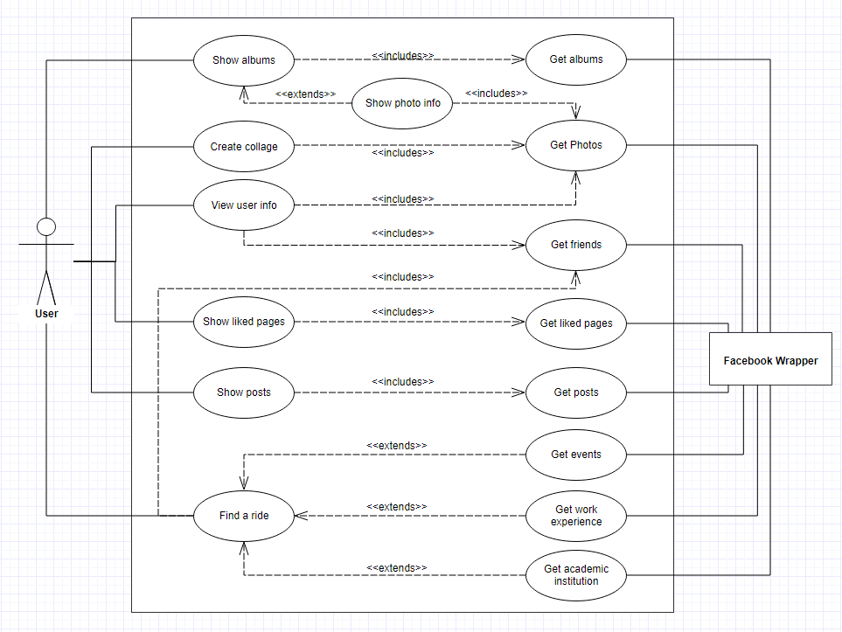

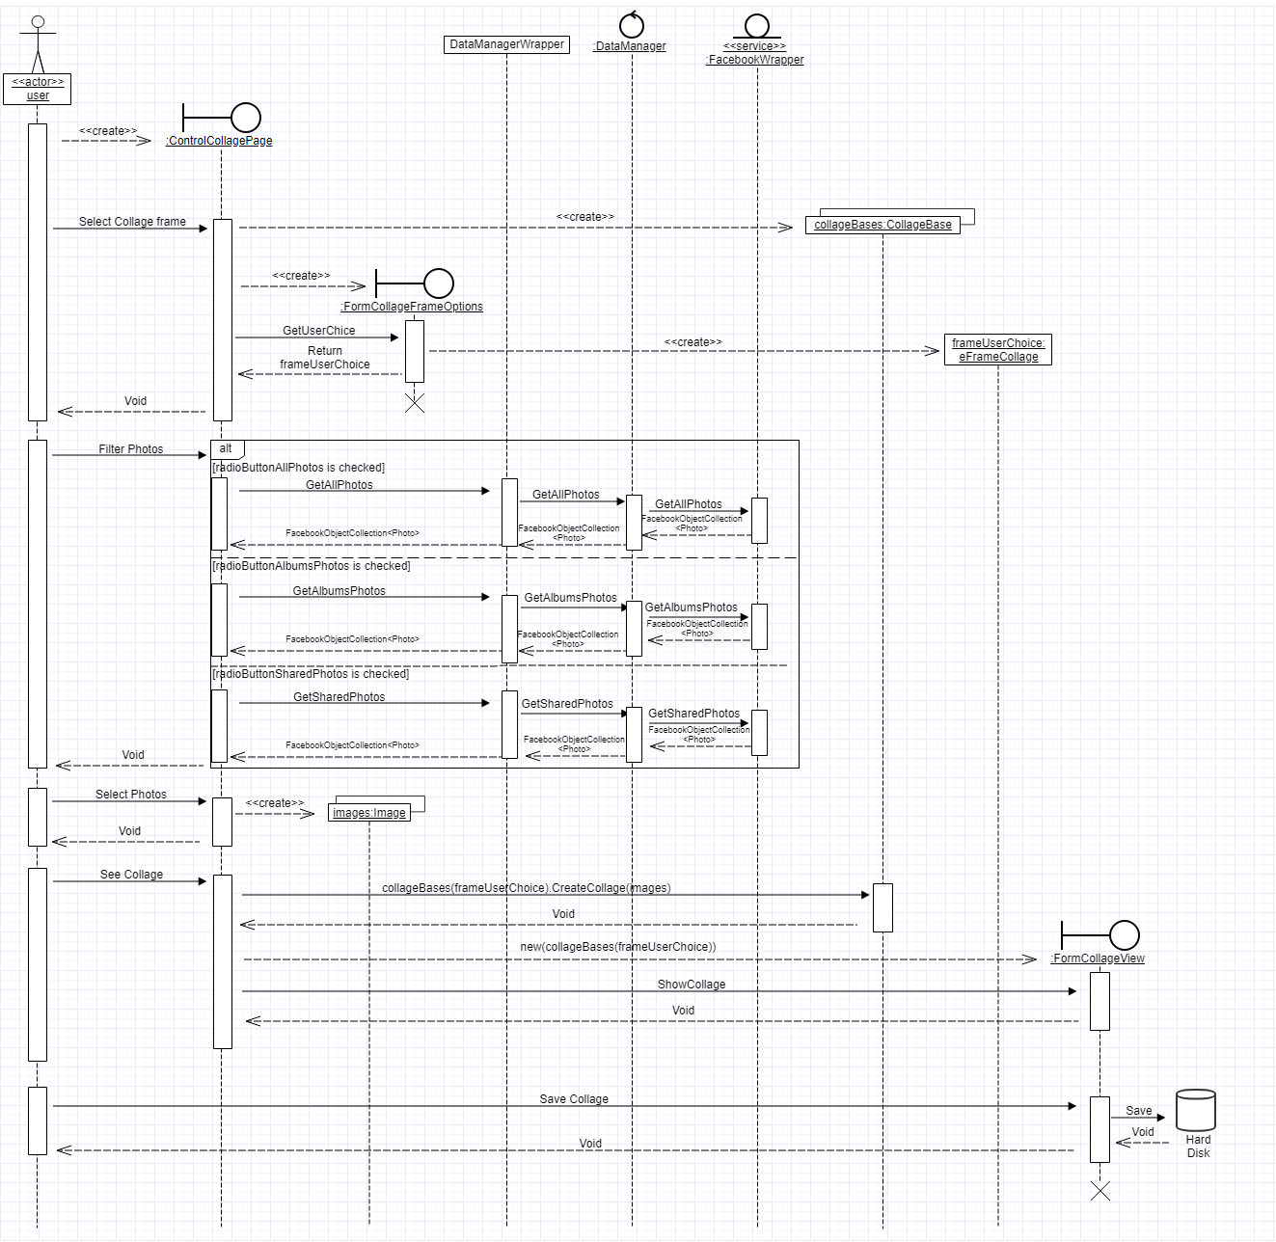**Collage- Sequence Diagram:**

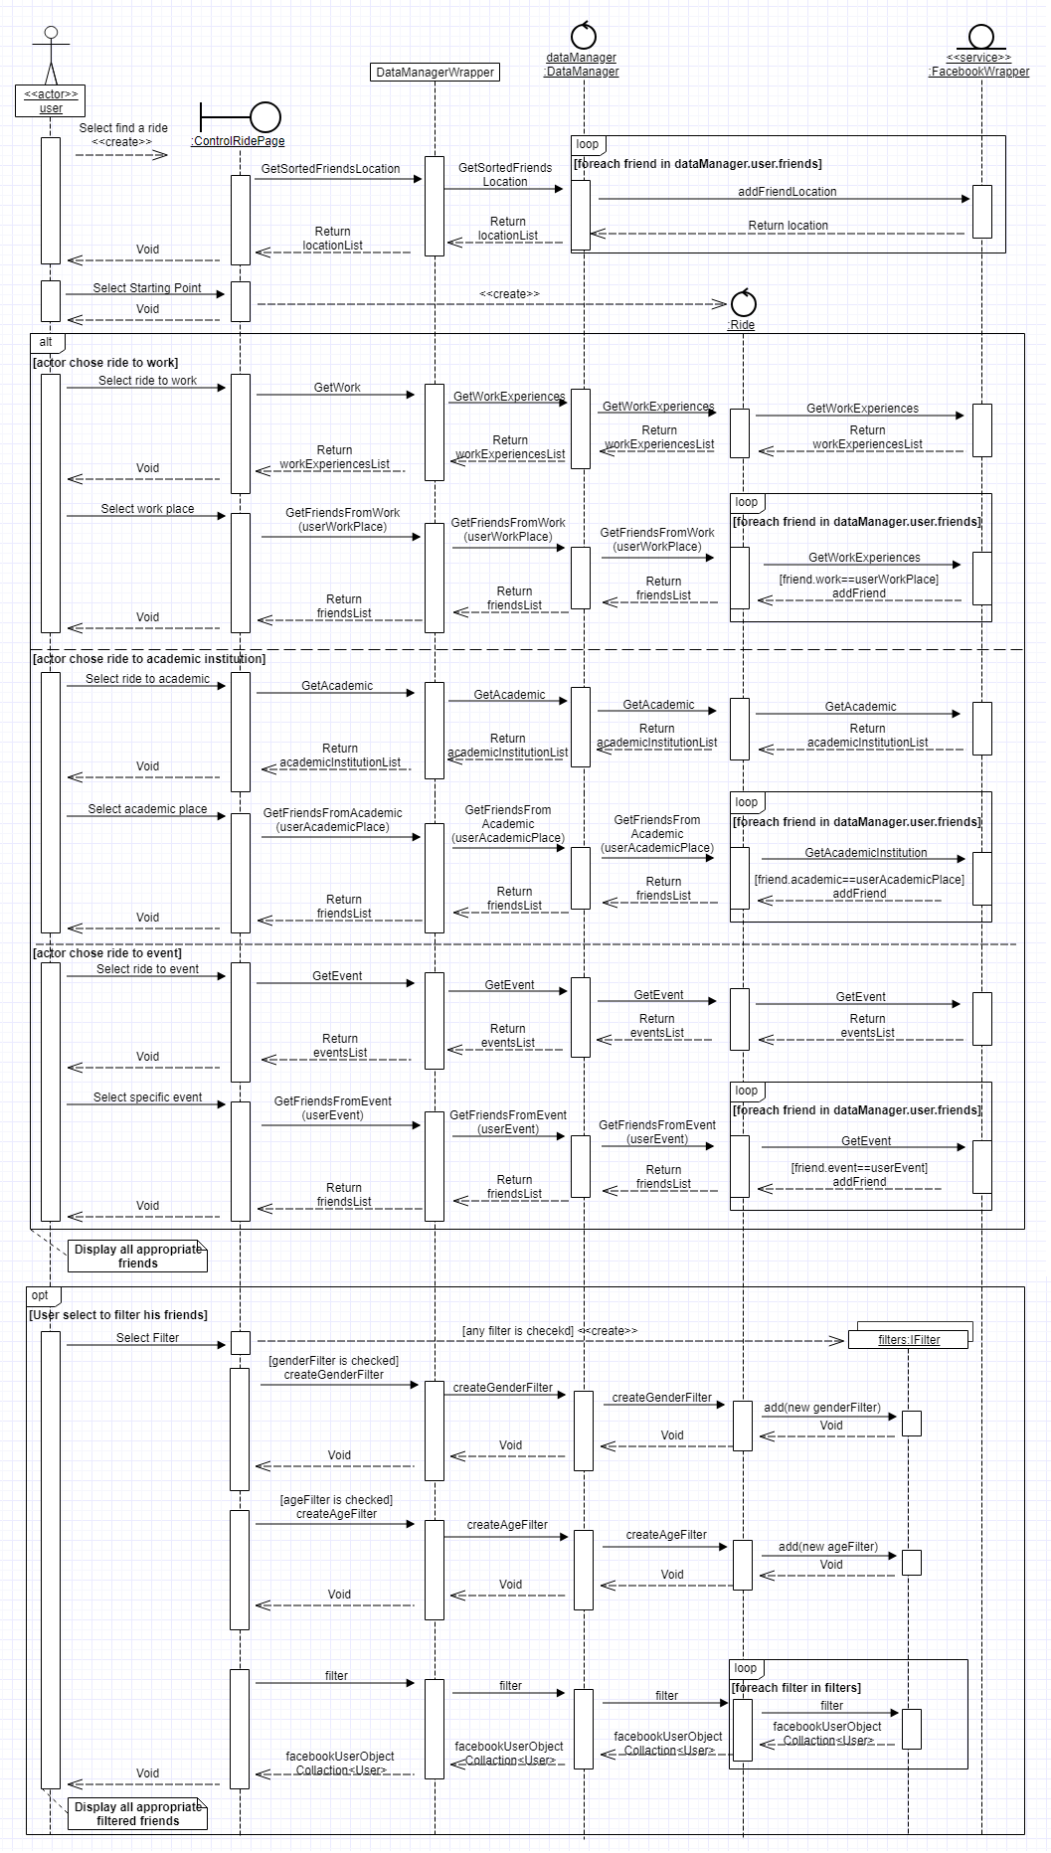**Find A Ride- Sequence Diagram:**